

By Ohad Badhav, Elizaveta Sidorova, Snir Ben Nissim

**General Game Overview:**

* The Casino game offers an immersive multiplayer experience where players can create their own gaming rooms or join existing ones. This platform facilitates collaborative gameplay, allowing users to come together and enjoy a variety of engaging casino games. Through seamless connectivity and innovative features, players can experience the thrill of the casino from the comfort of their own devices.

**Seamless Connectivity and Immersive Experience:**

* Our project stands out by swiftly connecting players with nearby friends through our location detection feature, fostering a seamless and immersive casino experience. This unique functionality removes the necessity of adding friends to a list; instead, players can effortlessly join the game together simply by being in close proximity. Furthermore, our game redefines the casino experience by allowing players to participate directly from their mobile phones, while the main "table" is projected onto a shared main screen. This innovative approach ensures that all players in the same room can fully immerse themselves in a genuine casino atmosphere, creating an unparalleled gaming experience.

**Enhanced Social Dimension:**

* While some multiplayer casino games exist, many lack the ability for players to join rooms with their nearby friends. In other words, while they may facilitate multiplayer interactions, they often overlook the opportunity for players to easily connect with friends in their vicinity. This limitation can detract from the social aspect of the gaming experience, as players may prefer to engage in casino games with familiar faces or acquaintances nearby. By incorporating a feature that allows players to join their nearby friends' rooms, our game enhances the social dimension of the casino experience, providing players with the opportunity to engage in a true casino atmosphere where the mobile phone serves as the player's hand and the main screen as the table. This addition distinguishes our game from others in the genre, providing a more immersive and enjoyable multiplayer experience.

**User Engagement and Room Management:**

* Our target users consist of groups who share an interest in casino games and prefer playing together. Additionally, individual players in proximity to others may spontaneously gather to enjoy gaming sessions collaboratively. The focal point of the game revolves around creating and joining rooms. When creating a room, users are presented with a screen to select their preferred game, such as Poker or Blackjack, among others. Upon joining a room, users can browse a list of available options. Upon requesting to join a room, the room's creator receives a notification displaying the player's Avatar, name, and balance. The creator then has the discretion to accept or deny the request. Upon opening the application, users encounter a login/sign-in screen. Room creators have the ability to stream the game on a separate screen, displaying relevant features for all players, while individual mobile devices showcase each player's unique features.

**Game Variety and Interactive Features:**

* Our game boasts a diverse selection of casino games including Poker, Blackjack, Wheel of Fortune, and Horse Racing. Using our location detection feature, players can swiftly join games with their nearby friends, providing an authentic casino experience as they play alongside others at the same table/ same screen.

Our game utilizes nearby detection technology to create a unique and seamless gaming experience, enabling players to swiftly connect and enjoy the excitement of the casino with their nearby friends, without the need for complex friend lists or cumbersome invitations.

Our game introduces the mobile and main viewer feature to enhance the casino gaming experience, providing players with the unique opportunity to participate directly from their mobile devices while simultaneously enjoying a shared table view on the main screen. This innovative approach improves immersion, fostering a genuine casino ambiance where players can seamlessly interact and compete in real time.

**Dependencies and Frameworks: W**

* We are expected to use the Unity engine, along with the C# scripts.

We use “Mirror”- networking library for unity for communicating with nearby devices.

In addition we will use the Azure/AWS/GCP cloud services.

Top of Form

* The login/sign-in screen:

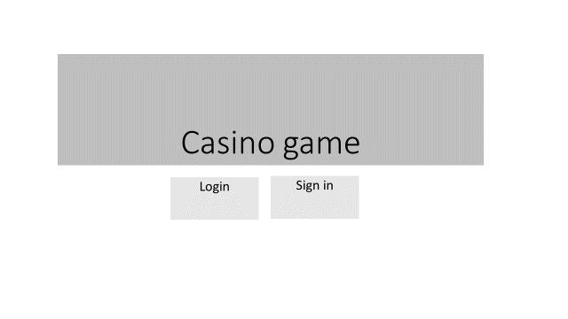

* 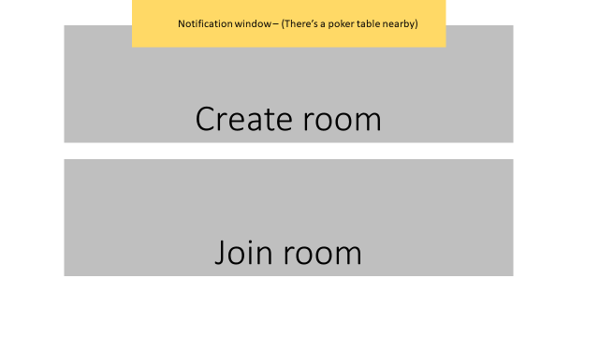The main screen:
* 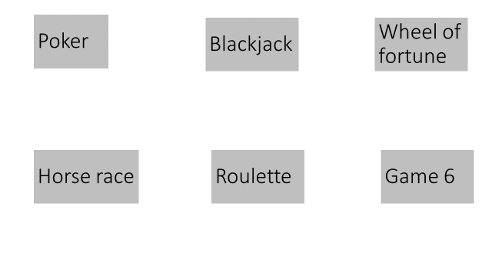The room creator:
* 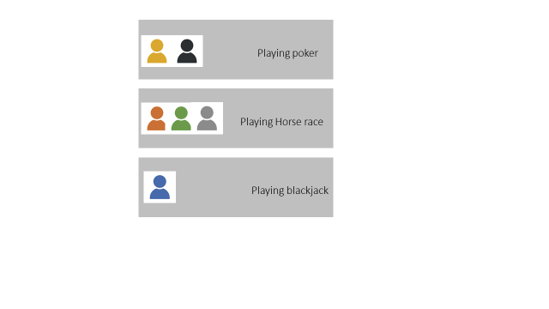The room join lobby:
* 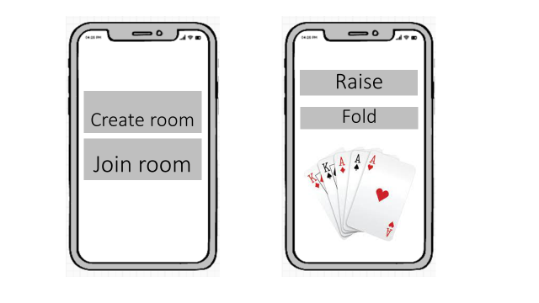The mobile view:
* 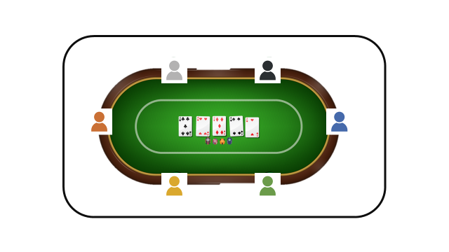The shared screen: